# Chapter 5

Tendering Opportunities

# Multiple Requirements in a Project

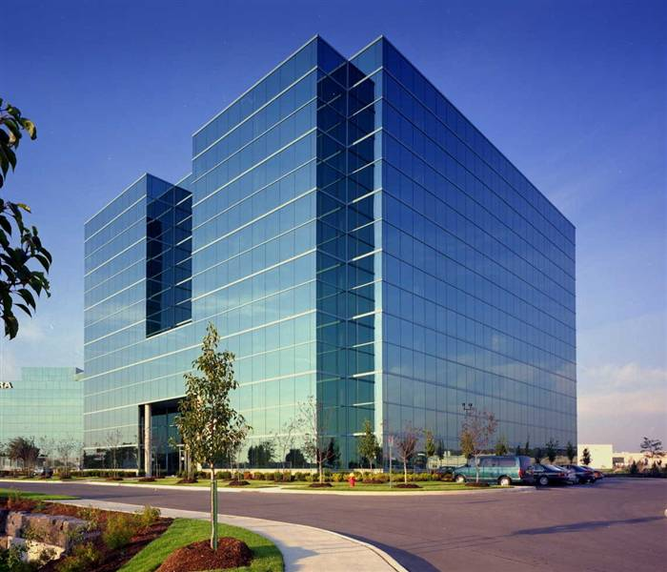

After becoming familiar with the departments of both central and provincial governments in the previous chapter, it is appropriate to discuss what kind of material, goods or services are required by these departments. An example will help to explain the point. Health department is an important organization in both central and provincial governments. It is a very big department with lots of attached departments and autonomous bodies like hospitals, rural health centers, basic health units, medical research laboratories, immunization programs, medical & dental colleges and so on.

If we suppose that the government plans to build a hospital to cater the needs of a fast growing city. It will require the services of a wide range of consultants, contractors, sub contractors and suppliers. A hospital is a public place with special requirements. This project demands careful planning, state of the art construction, central sterilization, sophisticated equipment and round the clock supporting services like laundry, medical gases and food items etc.

You can assess from this example that a single project can provide business opportunities to a large number of contractors and suppliers. It is up to you to decide which of your product match with the specifications of items demanded in a tender. A list of different goods or services which will be required in the construction of a hospital is given in detail in the following pages.

**Construction of a Hospital**



The services of the following consultants, contractors and suppliers may be required in the construction of a hospital.

**Management Consultants**

Planning & feasibility of the project.

**Architectural Consultants**

Designing of the building.

**Building Contractors**

Construction work.

**Building Material Suppliers**

Supply of bricks, sand, cement, tiles, and other building material.

**Pipe Manufactures**

Supply of different types of pipes.

**Office Equipment Suppliers**

Computers, fax machines, photocopiers etc.

**Fire Fighting Equipment Suppliers**

Smoke detectors, fire extinguishers, etc.

**Electro Medical Equipment Suppliers**

Medical and surgical equipment.

**HVAC Contractors**

Air conditioning, heating and ventilation.

**Medical Gases Manufacturers**

For operation theater and wards.

**Linen Suppliers**

Bed sheets, towels, pillows, etc.

**Requirements on Regular Basis**

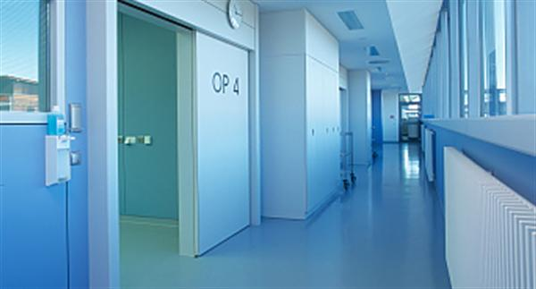

The following services or products may be required on ongoing basis in a hospital.

* **Dietary Items for Patients**
* **Washing of Linen**
* **Sterilization of Equipment**
* **Maintenance of Building**
* **Maintenance of Equipment**
* **Security Services**

**Commonly Demanded Items/Services**



A list of some commonly demand items and services is given below. You can tick and select a few categories to start with.

|  |  |
| --- | --- |
|  | |
| Auction of All Kinds/Scrap |  |
| Audio Visual Equipment |  |
| Automobiles/Cars |  |
| Architecture/survey |  |
| Arms/Ammunition/Security Equipment |  |
| Air Conditioning/Heating/Ventilation |  |
| Agricultural Machinery |  |
| Bi-cycles |  |
| Building Material/Paints |  |
| Books/Journals/Printing |  |
| Computers Software/Hardware |  |
| Constructions (Roads) |  |
| Cereals |  |
| Canteen/Catering/Food |  |
| Cables |  |
| Civil works/Sewerage (Building) |  |
| Consultancy/Management/Tax/Accounts |  |
| Cooking Oil/Ghee |  |
| Distribution of Products |  |
| Detergents/Soap/Janitorial Services |  |
| Electronics/Household Goods |  |
| Engineering/Turnkey Projects |  |
| Earthmoving Machinery |  |
| Electro-Medical/Scientific Equipment |  |
| Furniture |  |
| Ceiling/Exhaust Fans, |  |
| Foam/Mattresses |  |
| Fabrication |  |
| Crockery/Cutlery |  |
| Generators/Electric motors/Transformers |  |
| Hardware/Tools/Machinery |  |
| Horticulture Equipment/Services |  |
| Industrial Chemical/Medical Gases |  |
| Interior Decoration/Curtain/Carpets |  |
| Irrigation |  |
| Compressed Natural Gas (CNG) |  |
| Medicines/Pharmaceutical Supplies |  |
| Motor Cycles |  |
| Office Equipment |  |
| Octroi collection/Toll tax |  |
| Oil/Lubricants/Petroleum |  |
| Pipes all kinds |  |
| Poly Propylene Bags |  |
| Pumping Machinery |  |
| Property Dealing |  |
| Rubber items/V. Belts |  |
| Energy/Environment |  |
| Spare parts/Bearings/Tools |  |
| Stationary |  |
| Survey Equipment/Fire Fighting Equipment |  |
| Sanitary Fittings |  |
| Sewing Machines/Scale/Weighing Scale |  |
| Steel/Corrugated Sheets/Wires |  |
| Security Services |  |
| Tube wells/Pilling/Soil Investigations |  |
| Transportation/Rent a Car |  |
| Telecommunication/PABX/Wireless |  |
| Timber (Trees) |  |
| Tyres/Batteries/Auto spare parts |  |
| Tents/Tarpaulins |  |
| Uniforms/Cloth supplies/Shoes |  |
| UPS/Stabilizers |  |
| Veterinary Medicines |  |