# Lecture 3

Getting Started



Entering into tender business can be exciting as well as challenging. If you familiarize yourself with the tendering procedures and do your homework before participating in tenders you will feel much more confident.

Try to answer the following questions before considering starting the tender business. It will help you a lot to understand your own point of view about starting tender business.

# Why Tender Business

Why do you want to start tender business?

Is it a business that you want to build up and run?

Is it your side business?

What's in it for you?

How many people does it require? Who?

Requirements

# What equipment do I need?

What equipment is needed? i.e. Computer, Type Writer?

What space do I need to work out of? An office ? A room? Transport?

Do I have it now? Do I need to buy it? Could I hire or lease it? Could I borrow it? Is it essential or just desirable?

What quality do I need? Questions of quality come in here sometimes cheap is tempting, but not good in the long term.

How long does it last? 1 year, 5years?

Is leasing better because you can upgrade? And it's fully tax deductible.

If a bit of equipment is only used occasionally, buy or hire?

What are the tax implications/costs?

What impact will the general sales tax have?

# What consumables do I need?

This relates to the materials that are used up on daily basis. Possible questions are:

What consumables are needed?

How do I buy it? How much does it cost?

Where can I buy it? what suppliers are there? Wholesale? Retail?

How long does it last? How does it need to be stored?

What are the tax implications/costs?

What impact will the General Sales Tax have? What staff do I need?

# This relates to the staff requirements for tender business.

What staff is needed?

How many people do I need?

Who will do what work? Where do I get the people from? Do I know people I can use?

Who will handle and manage finances and money? What other costs are there?

What equipment needs servicing?

How much travel is involved? How much will this cost?

What banking and government costs are there?

# How long will it take to set up the tender business?

How long does it take to set up the tender business?

How long tendering process does takes?

How soon before the money comes rolling in?

# Is it worth doing the tender business?

How much would I make?

Is it a large proportion of my income?

Do I have to pay tax? What could happen if I don't? Does it depend on who I'm working for? How much does tax add up to?

What is the tax payable on different levels of tendering process?

What records do I have to keep?

What banking needs do I have to keep?

Do I need an accountant/bookkeeper?

How long will it take me/the bookkeeper?

Will the outgoing costs leave much of a profit?

What would that mean in profits per month?

The Check List

If you are facing any difficulty in answering these questions it may be appropriate to tick some of the check lists given in the following pages which will help you a great deal to reach the final conclusion of entering into the tender business. The more YES you tick, the more you are prepared for tender business 

Office Requirements

# Please tick the appropriate column

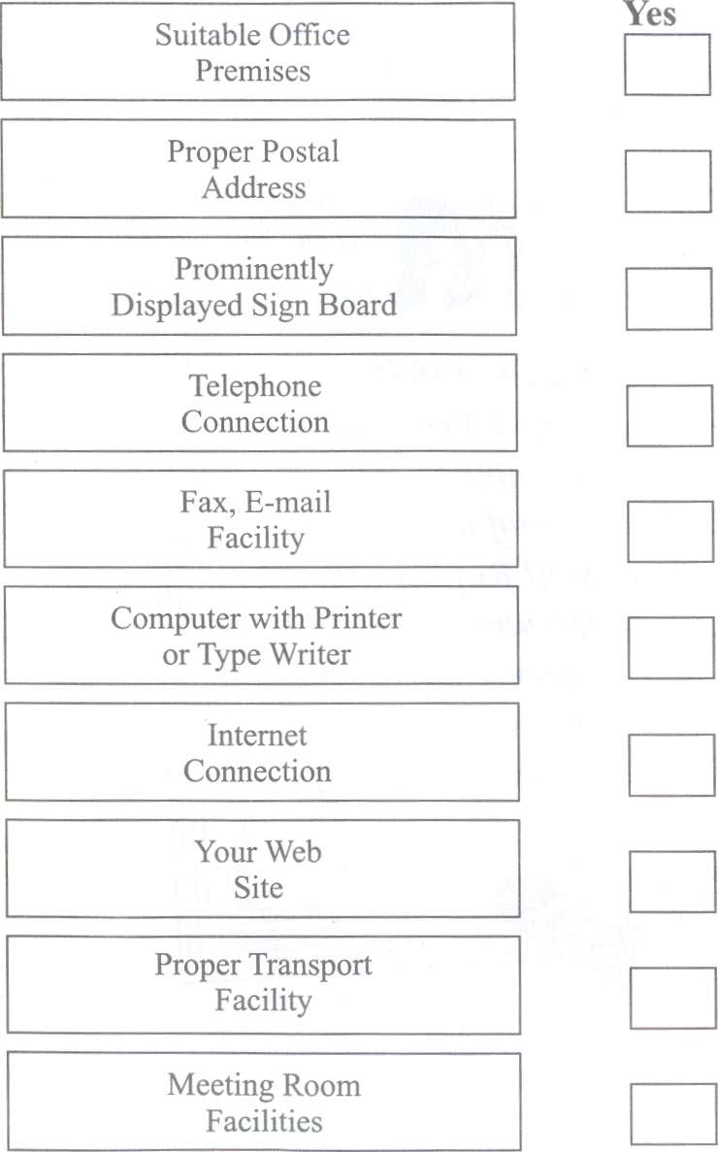

Capability as Manufacture

# Please tick the appropriate column

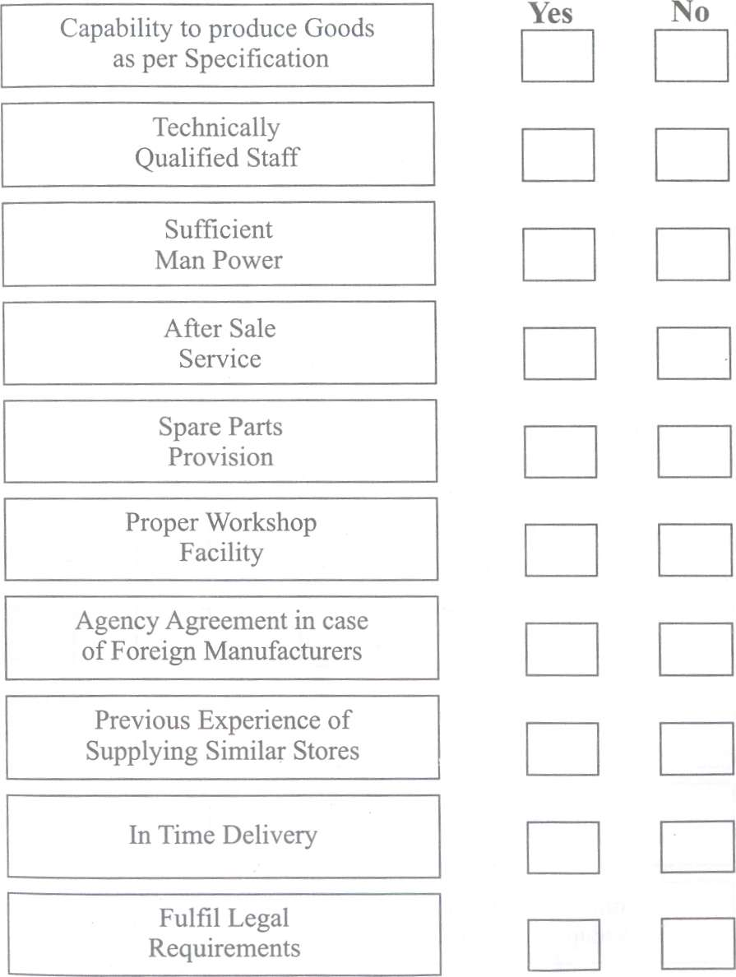

Documents Required

# Please tick the appropriate column

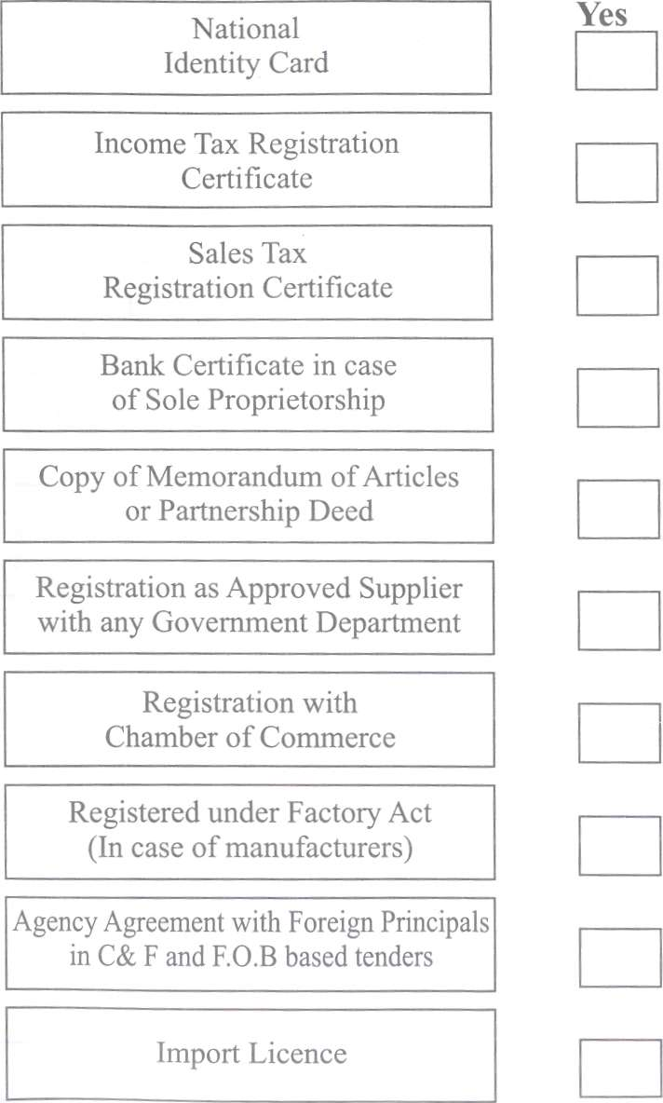

Staff Requirements

# Please tick the appropriate column

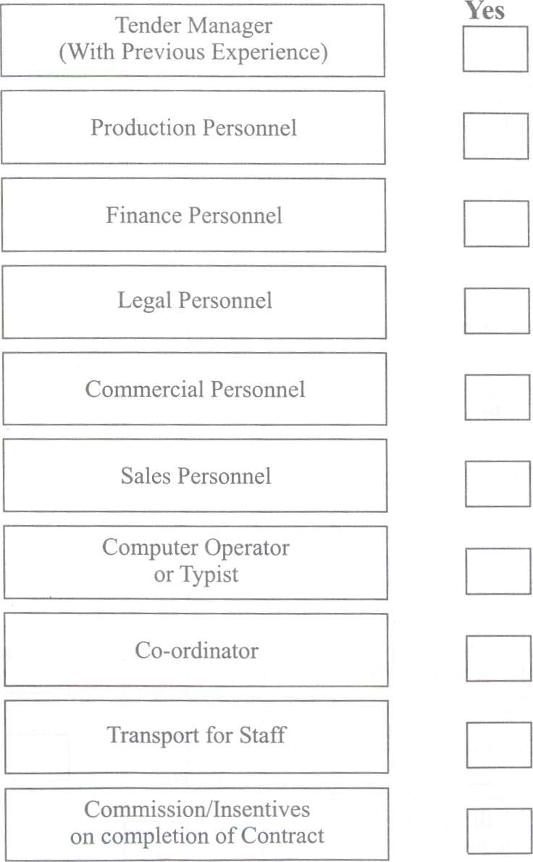

Information Resource Requirements

# Please tick the appropriate column

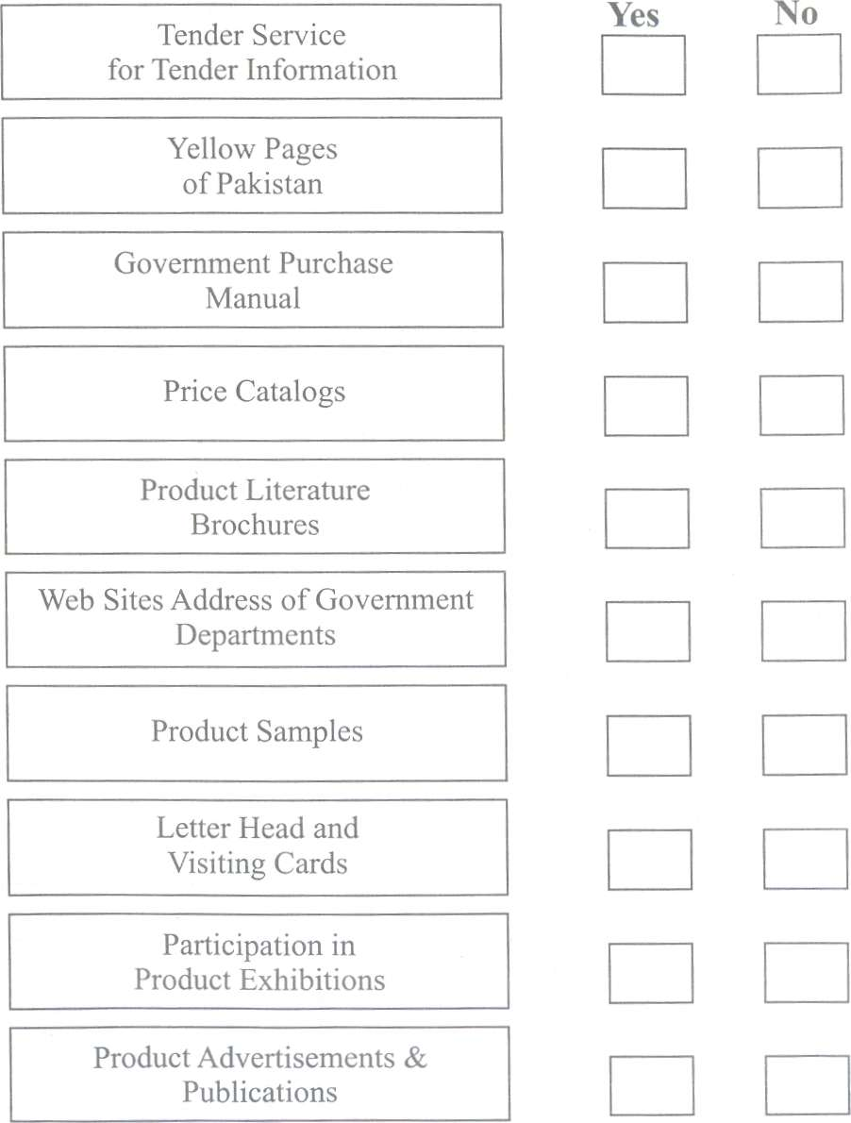

Credibility Requirements

# Please tick the appropriate column

