# Lecture 2

Advantages of Tender Business

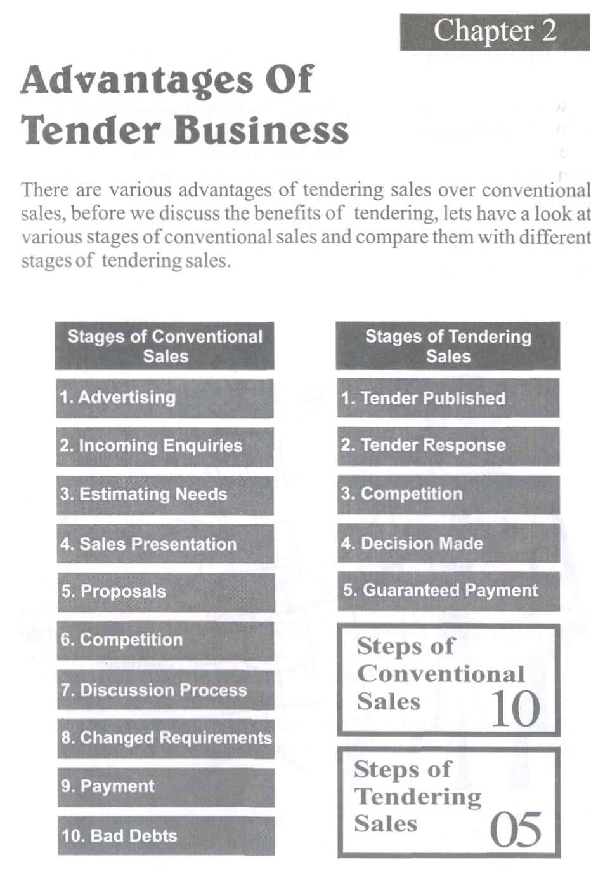

# Comparison

Note how in a sale by tender, the five stages still occur that occur in a conventional sale however, many of the other stages in conventional sale are avoided. If we look at the frustration in a conventional sale it's from these additional areas that most of them come from. Changed requirements and renegotiations midway into the sale causes sales managers and sales people the greatest headaches. In the view of the above comparison now we can summarize the benefits of sales through tendering.

# Table of Benefits

|  |  |
| --- | --- |
| Supplier’s Perspective | Purchaser’ perspective |
| * Guaranteed Payment * Known Parameters * Standardized Procedures * Less Over Heads * Long Term Values | * Value for Money * Effective Partnership * Improved Quality Product * Accountability and Transparency * Improved Service Levels |

Benefits from Supplier's Perspectives

# borat.jpg

# Guaranteed Payment

If we look at other forms of marketing such as advertising, telemarketing, direct mail and sales representation, there is generally a lot of expense involved in identifying clients who can use your service or product. It can take quite some time to get this cold market to the proposal stage of the sale, not to mention the often lengthy decision making process & changing requirements of each decision maker. Often initial sales to a new prospect have extremely low margins in the hope they will repurchase and at the end of the day we have to allow for bad debts.

It is from this view that tendering offers a fresh way to market your business. The prospect is already aware they need your services, they have already allocated a budget, payment is guaranteed (from government) and business starts at the proposal stage i.e. the tender.

# Known Parameters

Because of the logical purchasing procedures in a tender, there tends to be less changing of parameters. The objectives of both the purchasing organization & the sales organization are clear from the beginning. Dealing with organizations that have clear objectives, an established need, known requirement, set budgets along with a purchasing process to follow, make an ideal prospect to be dealing with when compared with the often frustrating changes involved in a conventional sale.

# Standardized Procedures

With the tender response you do not have to start from scratch. With every tender document you prepare, many key areas can be standardized and adjusted as required.

# Less Overheads

Once you have the tender in front of you, it is usually straight to the proposal stage. There is no advertising expense, no sales person's expense, no negotiation on price, no preferable treatment, every tender application is viewed upon its ability to meet the requirements of the tender.

# Long Term Value

Look at the long term value of a tender; even if you do not win the tender, perhaps the department still needs ongoing services or supplies that they have not requested in their tender brief.

For example; a tender for supply of a photocopier, may have simply requested the copier but there will be ongoing supplies related to the copier such as paper, toner, servicing, etc. Often by building a relationship with the organization who have put the work out to tender, you may find you will be able to provide other areas not included in the tender or assist in their ongoing requirements.

Benefits from Purchaser's Perspectives



The common benefits that government departments gain through tendering include:

# Value of Money

The value of money is gained through price efficiencies.

# Effective Partnership

Establishing effective partnership arrangements with the private sector that enables departments to gain access to world class expertise and access to international markets.

# Improved Quality Product

An improvement in quality and a vision for innovation is usually provided through suppliers competition.

# Accountability & Transparency

An improvement in accountability and transparency is gained through tendering process and open competition.

# Improved Service Levels

Greater internal flexibility and improved mechanisms such as service level agreements which can be measured and tied to a contract.

# Cost Benefit Analysis

A cost benefit analysis of tendering can be completed by the tendering department to justify a contract with a supplier or contractor, or to periodically re-confirm the merits of staying with the current provider. When completing a cost benefit analysis considerations are given to the following benefits that are cost related, management related and strategic related, as illustrated in the following table.

|  |  |
| --- | --- |
|  | Key Factors |
| **Cost Related** | |
| **•** | Convert fixed costs to variable costs. |
| • | Competition reduces costs. |
| • | Costs are fixed for a known period. |
| • | Overheads are reduced. |
| **Management** | |
| • | Services levels are known and guaranteed. |
| • | Service provider is accountable. |
| • | Issue of staff shortages resolved. |
| • | Performance levels improved. |
| **Strategy related** | |
| • | Strategic alliances are developed. |
| • | Focus on core business. |
| • | Gain from new technologies faster. |
| • | Flexibility for change improved. |
|  |  |