# Lecture 1

What is Tendering?



# Introduction

Each year, government departments, semi government organizations, autonomous bodies and large industrial units in Pakistan spend billions of rupees, buying a wide variety of goods, services and infrastructures from the private sector. This purchasing encourages fair & open competition between suppliers and aims to achieve the 'Best Value For Money'. Private sector suppliers & contractors, both large & small can effectively enter into this market which can open a new avenue of business for them.

To successfully become involved in this market, it is essential for the potential suppliers to recognize that the government is not just one unit, but a combination of many diverse departments, with unique needs. There are government departments throughout Pakistan, ranging in size from just a hand full of staff to several thousand and each has its own, varied purchasing requirements.

It is therefore essential for prospective suppliers to research & then accurately target the relevant departments most likely to utilize their goods or services and then negotiate the supply process. In this book, we will try to provide an overview of the current supply & contract environment and provide practical advice on how to become involved in "Tender Business".

# Definition

Tendering is the acquisition of goods and/or services. It is favorable that the goods/services are appropriate and that they are procured at the best possible [cost](http://en.wikipedia.org/wiki/Total_cost_of_ownership) to meet the needs of the purchaser in terms of quality and quantity, time, and location. Corporations and public bodies often define processes intended to promote fair and open competition for their business while minimizing exposure to fraud and collusion.

Some of the dictionary definitions of a "Tender" are:

-A tender is to offer in writing to execute work or supply goods at a fixed price.

-A tender is an offer to do or perform an act which the party offering, is bound to perform to the party to whom the offer is made.

-An offer of money; the act by which one individual offers someone who is holding a claim or demand against him or her the amount of money that the offer or regards and admits is due, in order to satisfy the claim or demand, in the absence of any contingency or stipulation attached to the offer.

- An unconditional offer made by one to another to enter into the contract of transaction of goods or services at certain specified cost. Normally government bodies and business groups issues notices for quotes for specified goods or services from other businesses which is known as tender.

-The dictionary definition of a 'Tender' is to offer in writing to execute work or supply goods at a fixed price. This really is describing what most firms do when preparing a proposal or quote in their normal course of business.

This really is describing what most firms do when preparing a proposal or quote in their normal course of business.

# How Tendering Started

There are many stories as to how tendering started. The most interesting one is given here. It goes back to when ships would come into a port and required provisions. The captain would put out a list of requirements on the port public notice board and the town merchants would respond with what they could supply and their price. This proved to be very effective for all parties as the captain did not always know the merchants and who could supply the best prices. The ship owner could see that the captain had paid the ongoing rate and the merchants were all given the same opportunities to offer their services.

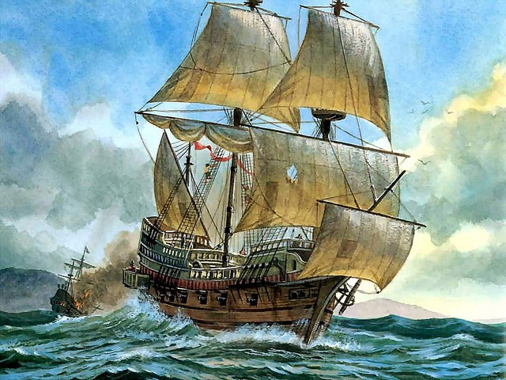

History of Tendering

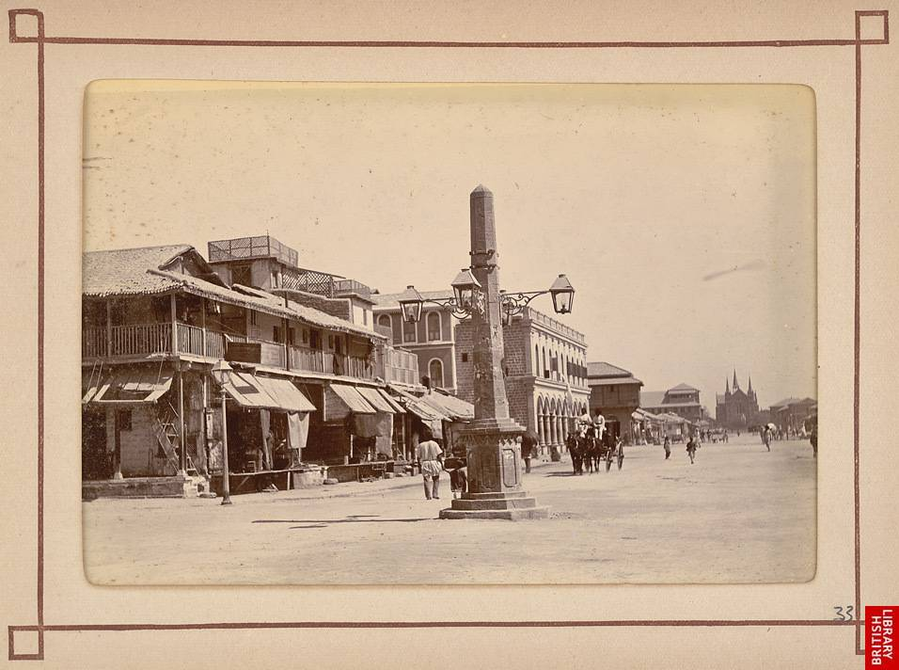

Prior to 1900, purchasing was recognized as an independent function by many railroad organizations, but in few other industries.

Prior to World War I, purchasing was regarded as primarily clerical.

During World War I & II – The function increased due to the importance of obtaining raw materials, supplies, and services needed to keep the factories and mines operating.

1950s & 1960s - Purchasing continued to gain stature as the techniques for performing the function became more refined and as the number of trained professionals increased. The emphasis became more managerial. With introduction of major public bodies and intergovernmental organizations, such as United Nations, procurement becomes a well-recognized science.

1970s & 1980s - More emphasis was placed on purchasing strategy as the ability to obtain needed items from suppliers at realistic prices increased.

1983 - In September 1983, Harvard Business Review published a ground-breaking article by Peter Kraljic on purchasing strategy that is widely cited today as the beginning of the transformation of the function from "purchasing," something that is viewed as highly tactical to procurement or supply management, something that is viewed as very strategic to the business.

1990s - Procurement starts to become more integrated into the overall corporate strategy and a broad-based transformation of the business function is ignited, fueled strongly by the development of supply management software solutions which help automate the source-to-settle process.

2000s - The leader of the procurement function within many enterprises is established with a C-Level title - the Chief Procurement Officer (sometimes called the Head of Procurement). Websites, publications, and events, and that are dedicated solely to the advancement of Chief Procurement Officers and the procurement function arise. The global recession of 2008-2009 places procurement at the crux of business strategy.

2010s - The elevation of the function continues as Chief Procurement Officers are recognized as important business leaders and begin to take on broader operation responsibility.

# Lecture 2

Why Government Purchase Through Tendering

# Scales1.jpg

# Fairest way to purchase

It still remains the fairest way for government to ensure that they have received the best offer from the market. Tendering gives parties the same time limits to respond, the same objectives to overcome and no preferential treatment.

# 

# No Personal Influences

Tendering does not allow for personal influences as every responding quotation is considered on the same level platform.

# Firms Selected On Merit

Firms that do win tenders have shown their skill at supplying a particular solution to the tendering board. They have taken extra care in preparing a submission that responds to all questions and requirements asked and added where they felt it gave them an edge over their competition.

# Less Chances of Rigging

Those firms that lose often blame the process before looking at the submissions themselves. Although over the years we have heard many complaints about a tender being "rigged", and many have carried real weight, but tendering can still be the most transparent mode of purchase if the rules and regulations are strictly followed.

# A Joke or Reality

An experienced person met a rich person and gave him a proposal to start tender business. The experienced person concluded, "Sir, if we can start tender business our fortunes are sure to change". The rich man asked him, what he meant by changing the fortune. The person said, "Sir it is very simple. After some time your money will become mine and my experience will become yours".

# The Nine Step Guide to Tendering

The diagram shown on the next page is the nine-step guide to tendering. It shows what you need to do to progress through the various steps of the tendering process.

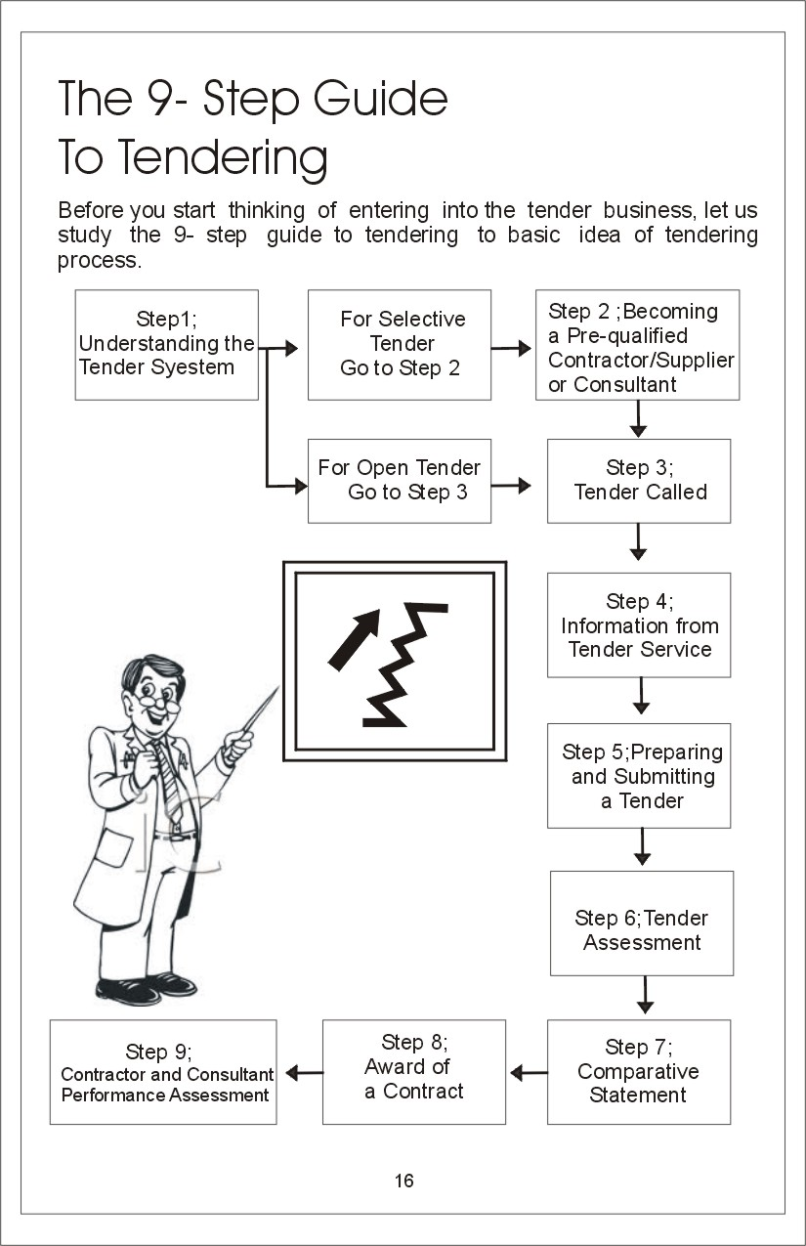

**Step 1**

You will first need to familiarize yourself with the different types of tendering. This will help you to decide that which type of tendering opportunities best suit your firm.

**Step 2**

To tender for selective or pre-registered tenders you first need to become pre-qualified as a contractor or a supplier. Open tenders do not need pre-qualification.

**Step 3**

Tells you what happens when a tender is announced. This is particularly relevant to those who are tendering for open tenders.

**Step 4**

Tells you that tender information is provided by **"Tender Service"** from all the major newspapers of Pakistan.

**Step 5**

Describes how to prepare your tender and what conditions you must abide by when you submit it.

**Step 6**

Outlines what criteria government will use to assess your tender and how these will be applied.

**Step 7**

Describes how government make comparison between different quotations for a tender.

**Step 8**

Describes how government will formalize a contract with you.

**Step 9**

Describes how government will then assess you on how you carried out your contract. Your performance on contracts will be taken into account when considering you for future business opportunities.

All these steps are explained in detail in future lectuers.