# Lecture 12

Tendering Procedure



We have discussed the responsibilities of different officers involved in the purchasing process. In this chapter we will elaborate the different steps of tendering procedure.

A simplified version of the tendering process from the supplier's perspective as well as from the purchaser's perspective is given in the following tables. For easy understanding the details of the procedure are then discussed step by step.

# Tender Enquiries

Purchase officer prepares and issues the invitation to tender.

All tender enquiries are properly displayed on a notice board of the department.

Individual notices are sent to registered contractors even if, the tender is advertised.

Sufficient time is allowed in all tender inquiries for calling of quotation.

# Validity of Offer

Chief Purchase officer/principal purchase officer fix a suitable period for which the tenderers are required to keep their offer open.

In case of C&F/F.O.B. tender enquiries and those on local currency basis requiring testing of samples. The tenderers are required to keep 45 days. In other cases this period is not less than 30 days.

# Tender Box

The tenders received are kept in the tender box.

Tender box is kept at a prominent place under the supervision of the concerned purchase officer.

The key of the tender box is kept in the safe custody of the officer.

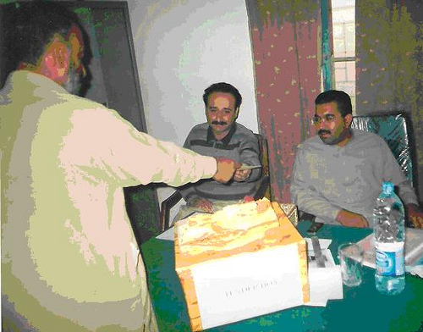

# Submitting Tender Documents

The limited or advertised tenders are not received by hand.

If the representative of any firm wants to hand over any tender, he has to place it personally in the tender box.

If the tender is bulky and cannot be inserted in the tender box, the officer holding the custody of the tender box, keeps that tender in his almirah.

The tender received should be in a sealed cover.

# Tender Box Opening

The officer, who has the responsibility for keeping the tender box, opens the box on the prescribed date and time

He signs on all the tender covers.

The tenders are sorted out and tender slips are prepared in duplicate after making entries in the register maintained for the purpose.

Opening of Tenders

# Opening in Public

All tenders regardless of their number and value are opened in public by two purchase officers nominated for the purpose.

# Announcement of the Conditions

The officer opening the tenders can on request announce any additional condition of the tender other than already announced.

# Serial Number

Serial number is given to every tender and total number of tenders received is also indicated.

# Page Number

Page number is given to every tender by the officer who opens the tender and he also indicate the total number of pages contained in the tender on its title page.

# Attendance Sheet

After opening the tender, the officer gives the attendance sheet to the representative of the participating firm to fill the relevant columns.

# Corrections

All corrections/over writings found in the tender are announced in front of representative of the participating firms, in addition all over writings and corrections to the rates quoted, by the tenderer is re­written by the officer and he signs it. This fact is recorded in the certificate signed by the representative of the firms, present at the opening of the tenders.

# Examining the Offer

The concerned purchase officer carefully examines the received offer, before it is passed to the technical officer for inspection of the particulars of the store offered.

# Blank Tenders

If any quotation is left blank by the tenderer, it is noted and cancelled by the officer who opens tender. The tender opening officer draws a line across the blank space and sign to indicate that the entry is left blank by the tenderer.

Acceptance of Offer not on Prescribed Form

# Registered/Renewed Firm

If the registered or renewed firms send their quotations, on their letter form instead of prescribed tender form against the advertised or limited tender, purchase officer may consider such quotation. But these quotations must be received in time and it is also required that tenderer must pay prescribed tender fee and also confirm in the prescribed manner that he accepts the general and special conditions of the contract.

# Unregistered/Unknown Firms

The unregistered/unknown firms can not avail/enjoy this facility of sending tenders on their letter heads, they must fill the prescribed tender form

Ignoring of Offers

Following are the some of the reasons of ignoring of the offers.

# Without Earnest Money

If an unregistered firm for particular store submits the offer without earnest money.

# Received Late

If the offer is received late after the date and time fixed for its receipt.

# Unsigned Offer

If the offer is not signed.

# Offer is not Clear

If the offer is not clear or it is ambagious.

# Validity Period

If the offer has a shorter validity period then required in the tender enquiry.

# Received by Telegram

If the offer is received by the telegram.

# Offer by Black Listed Firm/Suspended Firm

If the offer is received by black listed firm, suspended firm or by firm removed from approved firm list.

# Not Confirmed Condition

If the offer does not confirm general conditions of the enquiry.

# Conditional Offer

If the offer is conditional.

# Not Appropriate Offer

If the offer for a store material is substantially different from that required in the tender enquiry.